**Standard Operating Procedure**

**Hydra Crane Operation**



**ODISHA MINING CORPORATION LTD.**

**KODINGAMALI BAUXITE MINE**

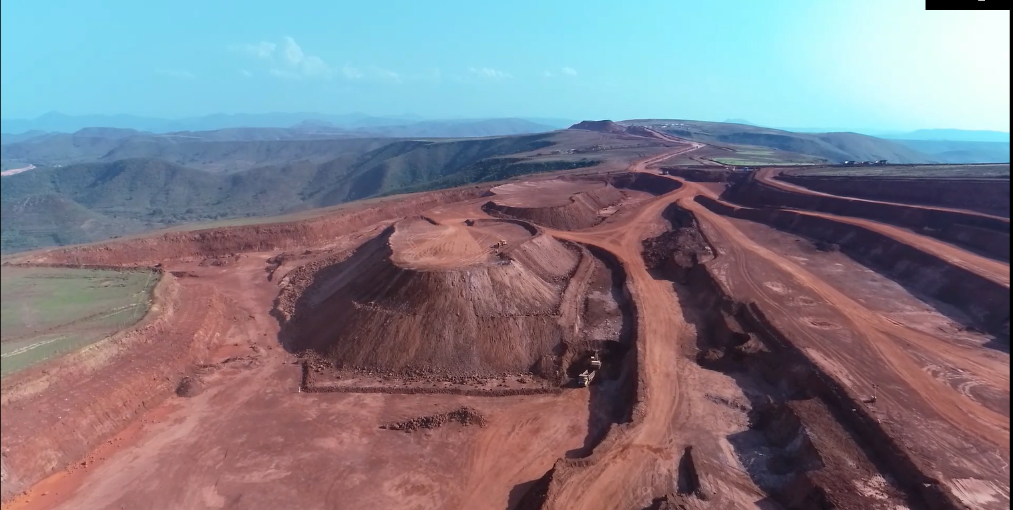

**Authorized By**

1. **Scope and Field of Application:** Procedure is to establish safe operation with respect to any type of lifting and shifting using Hydra crane. Lifting shall be taken as a non-routine job hence proper Permit to Work shall be followed strictly.
2. **Accountability:** Mechanical I/C

|  |  |  |
| --- | --- | --- |
| 1. **PPE:** 2. Safety helmet 3. Safety shoe 4. Nose Mask 5. Fluorescent jacket 6. Safety goggles. | **Tools:**   1. Slings 2. D Shackles | **Training needs:**   1. Line of Fire 2. Work at height 3. Work Permit 4. Electrical Safety 5. Usage of PPEs 6. Safe operation of Crane |

1. **Responsibility:**

It shall be the responsibility of mechanical Incharge, who shall work along with safety officer and training officer to implement this standard.

1. **Definitions:**

**Operator:** One with relevant experience and had undergone training after authorization by Mine Manager shall be called as operator/

**Emergency Operations:** Operation that in any means if include interaction with fire, electrical power lines, loss of stability or control malfunction.

1. **Procedure:**
2. The cranes will be under the control of the mechanical department.
3. The crane operator and mechanical department will ensure that the required slings and D shackles are available in the tool box of the crane.
4. The crane will always be operated and moved from outside the garage area to other location with a permit issued by mechanical department /Safety department in the prescribed format.
5. The crane will be operated by authorised crane operator for lifting and shifting heavy material with one rigger and one helper at all times.
6. The user departments 1.Mechanical 2.Crusher & Screening 3.Stores 4.Production 5.Civil 6.Camp or any other department requiring the crane for any shifting and lifting work will contact the mechanical head / shift I/C of the particular mines. On getting the requisition for use of crane point no 3 & 4 points should be followed strictly as permitted by mechanical i/c.
7. The mechanical department should ensure that the crane is certified for fitness including the lighting and safety light of the boom before allocating for any work.
8. Mechanical I/C shall ensure proper maintenance of crane and shall release it for operation after certifying it fit for operation.
9. Prior to operation a site inspection shall be conducted to asses site safety by the mechanical Incharge, safety officer and user department i/c.
10. Operator shall only take the crane when approved by mechanical Incharge.
11. Operator shall maintain operator checklist a bound paged book to be filled to check the working of crane.
12. The Crane movement on highway road after darkness should be strictly avoided, if the crane has to be moved on highway for emergency work- one pilot vehicle will lead the crane with two security guards one on crane and one in the pilot vehicle with signal torches.
13. When the crane is moving on highway in day time pilot vehicle with security guards using red and green flag should accompany the crane.
14. Before the use of crane for any lifting and shifting of heavy material the safety department should be informed by the user department and permit will be issued by the safety personnel at site.
15. No operation shall be done without issue of permit to work.
16. Deviation of process shall be authorized by mine manager and properly documented.